Dear colleagues,

As 2022 draws to a close I take this opportunity to look back on a year full of accomplishments and achievements. While it was certainly challenging in many ways, it also showed us how strong we are as a company and as a team.

As we celebrate our successes, it is important to reflect on our performance this year, as individuals, as teams and as a Division. I expect there to be no surprises in the year end conversations between you and your managers, since we have already championed regular performance-related conversations throughout the year.

Remember that the year-end evaluation focuses on the bigger picture of your performance; the “what”- how successful you were at achieving your goals and the results you delivered and the “how” - the Values, mindset, and behaviours you used to get there. Focus on this time as an opportunity for self-reflection, feedback, and aligning with your manager on your key achievements & strengths and how these can be further leveraged in the expectations for the coming year.

When it comes to evaluating your performance rating, I ask you to have candid conversations, that are truly reflective of your performance journey during the year. I always stress that a ‘fully performing’ rating is a strong benchmark of someone performing at the high standard that we expect of you in Al-Futtaim. This is the time to sum up your personal performance within your role, and your impact and contribution to the wider agenda.

I count on your commitment and dedication to complete your self-evaluation and line manager conversation before 31st January 2023.

Thank you for your continued dedication, commitment and hard work.

I wish you and your families all a happy holiday season.

Dear Colleagues,

As we Start a new year, it is important that we are enabling the business to close off the PM 2022 cycle successfully. At present we are only at 8% completion across the online organization, which means that we need a further concerted effort to move the needle forward and effectively close off all evaluations by January 31st of Jan.

To support you further we have created a variety of education options:

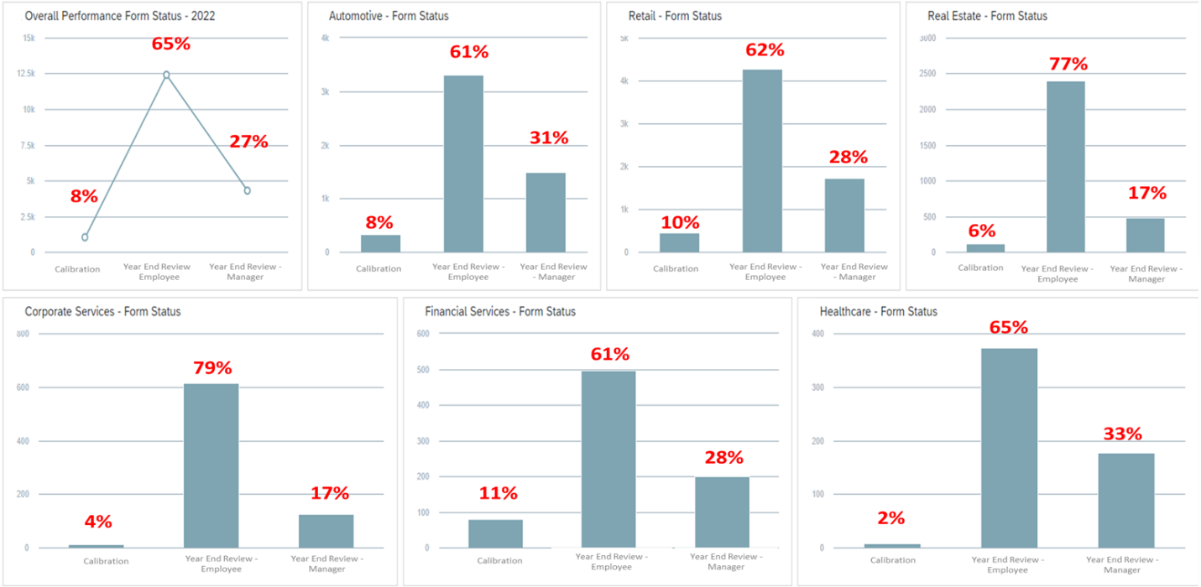

- We have run two sessions around Driving an effective Performance Evaluation conversation in December, one in English and one in Arabic educating employees to close off the cycle successfully, We will run additional sessions during the month of January for both employees & people managers in both languages, date & time is shared in the HR communication. Below are the dates:
  - 14th of December è For Employee In English
  - 15th of December è For Employees in Arabic
  - 11th of January è For People manager In English
  - 12th of January è For People manager in Arabic

- We prepared a tool kit that HRBPs can leverage further to run additional education sessions within the Divisions Yearend Evaluation - 2022
- We will deliver education sessions to HRBPs next week to show them how to leverage the reports on IGrow for better tracking.
- We have attached the original email that has gone out to our employees and an email template, we would like your Presidents/ Directors or yourselves as HRDs to forward to your teams, if you have not done so.
- For more information employees can always review the Performance Management toolkit in SuccessFactors.

I am still waiting on a final OK from Mr Elamin on the calibration distribution (even though I do not anticipate a change from how things were approached last year) and will get back to you as soon as that is cleared. We count on your support to ensure we get to a successful closure of 2022.

Please feel free to reach out if there is any support you require from our end to facilitate the process.

